DBMS MANUAL LAB

Name: Mymoon Beevi.B Roll.No:230701201

**Working with multiple tabels**

**Ex.no.8:**

1.UPDATE EM1 SET DEPT_NAME = ‘CSE’; WHERE FIRST_NAME = ‘MOON’;

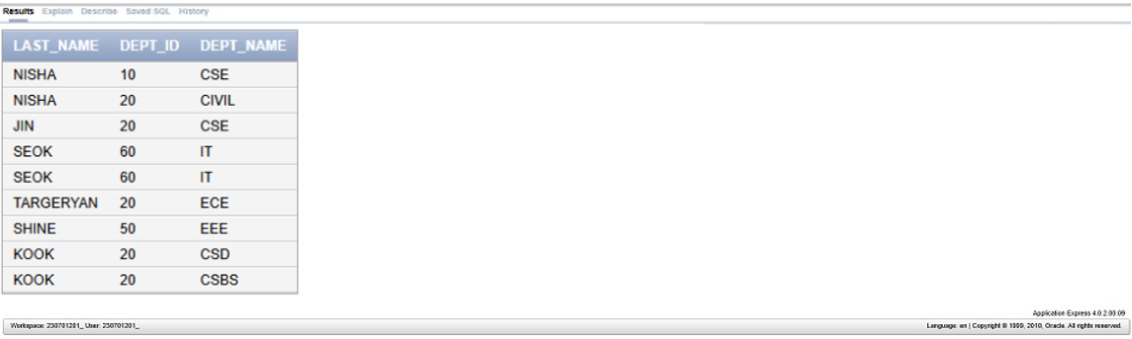

2. SELECT DISTINCT D.JOB_TITLE, J.COUNTRY_NAME FROM JOB J

JOIN EM1 D ON J.DEPT_ID = D.DEPT_ID

WHERE J.DEPT_ID = 20;

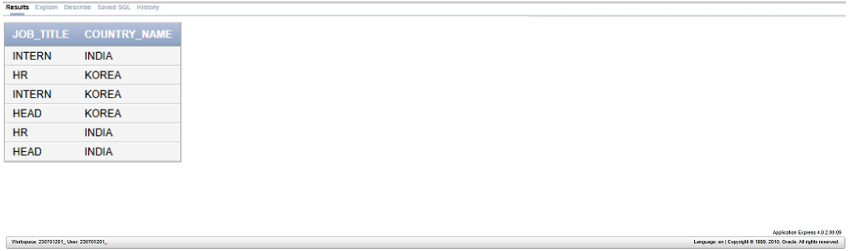

3. SELECT E. LAST_NAME, E. DEPT_NAME, J. LOCATION_ID, J1. COUNTRY_NAME FROM EM1 E

JOIN JOB_HISTORY J ON E.EMP_ID = J.EMP_ID JOIN JOB J1 ON J1.EMP_ID = E.EMP_ID

WHERE E. COMMISSION IS NOT NULL;

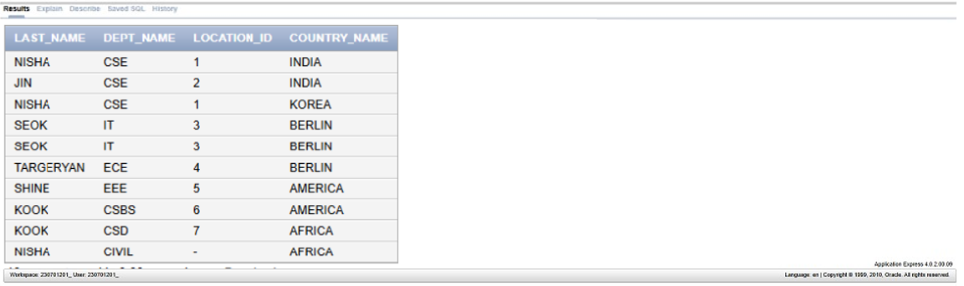

4. SELECT E. LAST_NAME, J. DEPT_ID FROM EM1 E JOIN JOB J ON E.EMP_ID = J.EMP_ID

WHERE E. LAST_NAME LIKE ‘%A%’;

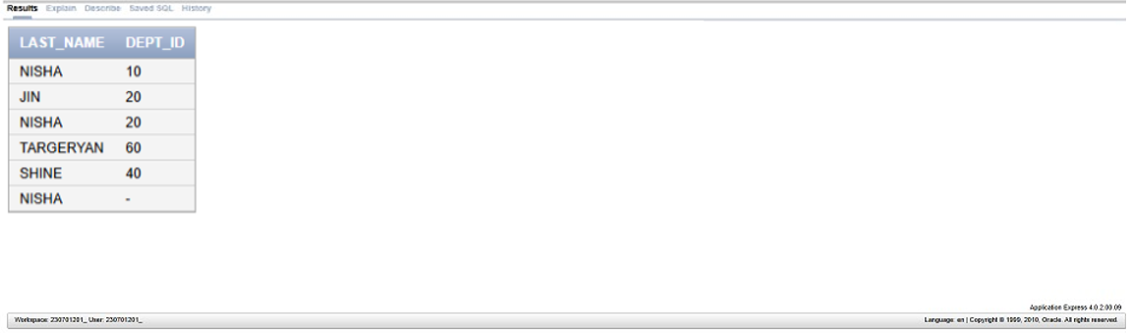

5. SELECT E. LAST_NAME, J. DEPT_ID, E. DEPT_NAME FROM EM1 E JOIN JOB J ON

E.EMP_ID = J.EMP_ID

WHERE J. COUNTRY_NAME = ‘BERLIN’;

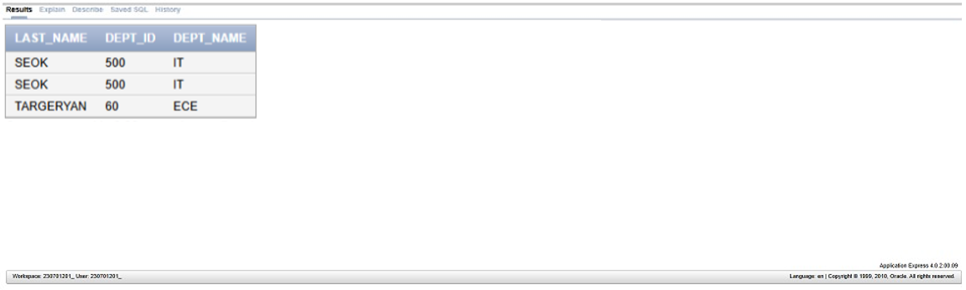

6. SELECT E. LAST_NAME AS EMPLOYEE, E.EMP_ID AS EMP#, M.M_NAME AS MANAGER, M.M_ID AS MGR# FROM EM1 E JOIN MANAGER M ON E.EMP_ID = M.EMP_ID;

